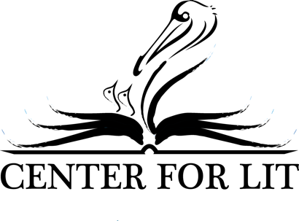

Missy Andrews: Lecture Titles

Would you like Missy to speak on something that does not appear on this list? Call (509) 563-9299 to make arrangements.

After Apple Picking: Conclusions, Confessions, and Callings
A retrospective of Missy’s 23-year career homeschooling six children K-12.

My Divine Comedy: A Mother’s Homeschool Journey
Everybody knows homeschooling gives mom a second chance at her own education, but what does that mean? Here’s what Missy learned.

Teaching Your Children to Find Themselves in God’s Story
A “how to” talk that presents a pedagogical approach to teaching children the greatest book, with an eye to helping them discover their true, gospel identity.

Biblioscopic Dialogues: What, How, and Why
How to study great ideas through children’s books.

Reading as Relationship: Loving Your Kids Through the Booklist
How to create personalized book lists as a relational ministry to your children.

Why Lit? Our World of Words
A reflection on the significance of figurative language and the power of mythopoeic literature.

Lit for Littles: Making Reading Magical
A demonstration of how sensory experience stimulates a lifelong love of reading.

Restorative Reading: Finding Community with the Great Authors
“Life is pain, your Highness.” So says William Goldman through the mouth of his character Wesley in the renowned cult classic, The Princess Bride. How can the great books help us ( and our children) cope with the pain, and find a path through it?

The Wardrobe Door: A Way into Worlds
The Pevensie children found a new world through the wardrobe in the spare room. We did too through Lewis’s classic Narnia tales. Can fantasy literature help us find the door into our own?

I’m Not Really Sorry: An Apology for Poetry
Poetry is a gift to the visual learner, and that means everyone. Poems make the abstract world of ideas concrete and objective. Here’s a quick primer on how to read them.

Baiting the Hook: Illustrated Invitations to the Classics
Read children’s books with my high schoolers? Why would I do that? Missy reflects on how the creative concept book creates a taste for the classics.

Meet and Greets With the Greats: The Relational Power of Biographies
We read their novels and poetry, but who are they, and why should we care? Missy explores the power of contextual reading, intellectual history, worldviews, and the intentional fallacy.

Hercules Overwhelmed: The Quest for Success and Enoughness

